**UNIVERSITY OF ENGINEERING AND TECHNOLOGY, LAHORE**

**(NAROWAL CAMPUS)**

**­**

**NAME :**

**ABDULAHAD HUSSAIN**

**ROLL NO. :**

**549**

**SECTION:**

**A**

**SUBJECT:**

**PROGRAMING FUNDAMENTAL**

**LAB #05:**

**Program No. 1:**

Write a program to convert temperature from fahrenheit to celsius degree.

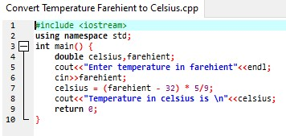

**Output:**

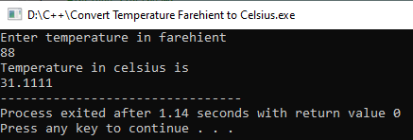

**Program No. 2:**

A company insures its driver in following three cases:

1. If driver is married
2. If driver is unmarried and male and his age >30
3. If driver is unmarried and female and her age >25

In all other case the driver is not insured. Write a program that take the marital status, gender and age of driver as input from keyboard and determines whether he is insured or not.

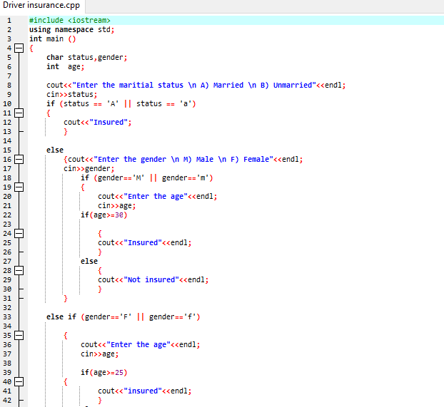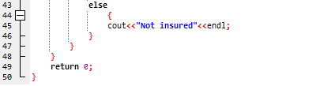

**Output:**

